Class
Use Case

Sequence diagram

Collaboration diagram
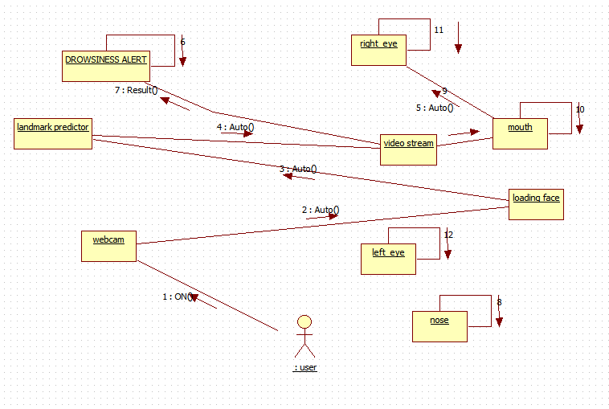
State Chart

Activate Diagram

Component diagram

Deployment

